INDIANA DEPARTMENT OF TRANSPORTATION

Guide to Outdoor Advertising

March 2020

Disclaimer
This document is designed as a guide to Indiana’s outdoor advertising control program and permit process. It should be considered a source secondary to the primary sources of law. In no way should this document be construed as offering legal advice. It should be used for educational and practical purposes only. The Indiana Department of Transportation (“INDOT”) assumes no liability for the use of information contained in this document.
The document is accompanied by (a) laws and regulations that govern outdoor advertising [as of January 24, 2020] and (b) related information.
Reading this document is not a replacement for reviewing those laws and regulations, including:
- the Indiana Code (IC),
- the Indiana Administrative Code (IAC),
- the U.S. Code (USC),
- the Code of Federal Regulations (CFR),
and the Agreement for Control of Outdoor Advertising between the State of Indiana and the U.S. Department of Transportation, executed August 4, 1971. Research involving additional authority beyond the laws and regulations accompanying this document may be necessary.
The permit applicant is responsible for having sufficient knowledge of the law to make accurate representations on a permit application. Nothing contained herein shall be construed as a guarantee that a permit application will be approved.

TABLE OF CONTENTS

Contents

Disclaimer 2
Introduction 5
Purpose 5
- Outdoor advertising control: Why, what, where, and how 5
  - Why does INDOT control outdoor advertising? 5
  - What is outdoor advertising subject to control? 6
    - What’s not included in “outdoor advertising” subject to control? 6
    - Forms of outdoor advertising 6
  - Where is outdoor advertising subject to control? 10
    - Control routes 10
    - Adjacent area 10
    - Right-of-way and encroachments 10
  - How is outdoor advertising regulated? 11
    - Location 11
    - Size of signs 14
    - Lighting of signs 15
- Permits: Conforming and nonconforming signs 15
  - Conforming signs 16
  - Nonconforming signs 16
- Permit application process 19
  - Contents of application 19
  - Permit addendum 21
  - Incomplete applications 21
  - Permit application approval 21
    - Notification of approval 21
    - Other permitting requirements outside of INDOT 21
    - Completion of permitted work 22
  - Permit application denial 22
  - Permit downgrade or revocation 22
  - Fee schedule for permit applications and other actions 23
- Required updates to permit records 23
  - Transfer of sign ownership 23
  - Other updates 23
- Keeping permit plates visible; other upkeep 24
  - Replacement plates 24
  - Vegetation removal/tree-trimming permit 24
- Walk-through of EPS permit application process 25
  - Registering for an account with EPS 25
  - Logging into EPS 25
  - Applying for a permit 25
  - Next steps after submitting the application in EPS 29
- Outdoor advertising permit FAQ 30
- Contact information 31

Introduction
INDOT is responsible for administering an Outdoor Advertising Program for the State of Indiana, and enforcing Federal and State laws and regulations, including administrative rules governing outdoor advertising in Indiana, which can be found at 105 IAC 7-4 (the “Rules”). INDOT personnel administering the program are guided by official sources of authority, including applicable laws, the Rules, and agreements with the Federal Highway Administration (“FHWA”).
The Guide to Outdoor Advertising (“Guide”) is a companion document to the Rules. The Rules outline a statewide uniform program controlling the use of advertising in areas adjacent to certain roadways. The intent of the Rules is to protect and promote the health, safety and welfare of the traveling public, and to promote the reasonable, orderly, and effective display of outdoor advertising while preserving and enhancing the natural and scenic beauty of Indiana.

Purpose
This Guide was created as a reference document for outdoor advertisers and interested members of the public regarding the control of outdoor advertising in the State. It is provided as a public resource available online to present information about INDOT’s outdoor advertising control program. Like many states, Indiana began a program to regulate outdoor advertising after the Federal government (through the Highway Beautification Act of 1965, or “HBA”) tied part of states’ Federal highway funding to effective control of outdoor advertising.
I.

Outdoor advertising control: Why, what, where, and how
Outdoor advertising control is one of many responsibilities of INDOT’s Permits Division. The following sections outline:
  - Why outdoor advertising is controlled
  - What is outdoor advertising subject to control
  - Where outdoor advertising is controlled
  - How INDOT controls outdoor advertising

Why does INDOT control outdoor advertising?
To provide “effective control” of outdoor advertising, INDOT has established procedures — through a sign permit system, inventories, and periodic surveillance of the controlled routes — in order to monitor outdoor advertising and areas controlled by the HBA, to discover illegal signs and take action toward their removal.

What is outdoor advertising subject to control?
ON-PREMISE SIGNS
A sign is an “on-premise” sign if:
- The message consists solely of the name of the establishment, or identifies solely the
establishment’s principal or accessory products/services offered on the premises; or
- It is a “for sale” or “for lease” sign advertising the property upon which the sign is located.
A sign is not an “on-premise” sign if any of the following apply:
- It brings rental income to the property owner.
- It advertises activities conducted on the property, but which also advertises, in a prominent manner, activities not conducted on the property. (Note: On-premise changeable message signs may NOT have any off-premise messages intermixed.)
- A sale or lease sign advertises any product or service not located upon and unrelated to the business of selling or leasing the property on which the sign is located.
- It is erected on a narrow strip* of land contiguous to the advertised activity when the purpose is clearly to circumvent the laws.
- The sign is separated from the property by separate land ownership.
- The sign is on property which has been secured subsequent to the establishment of the activity and purchased in a narrow strip.*
*A “narrow strip” includes any configuration of land which cannot be put to any reasonable use related to the activity other than for purposes of erecting or maintaining a sign or for the specific purpose to qualify an on- premise sign.
Indiana laws control outdoor advertising (a common example being billboards, referred in laws and throughout this document as “signs”) on certain roadways.
For outdoor advertising control purposes, a “sign” is an outdoor sign, display, device, notice, bulletin, figure, painting, drawing, message, placard, poster, billboard, or other thing that is designated, intended, or used to advertise or inform.

What’s not included in “outdoor advertising” subject to control?
  - “On-premise” signs, which are signs that advertise or identify:
    - Activities conducted on the property upon which it is located, or
    - The sale or lease of the property
  - Directional and official signs and notices (transportation signs, signs put up by governments, service clubs, and religious organizations meeting certain criteria)

Forms of outdoor advertising
The forms of outdoor advertising encountered on roadways will include a variety of types of billboards that display content in different ways or combinations, and advertising on other types of stationary things or structures.

Signs (billboards)
Billboard signs are the most common form of outdoor advertising.

Single face |  | One sign face, facing one direction of travel at a single location.
Back-to-back |  | Two sign faces, attached on each side of the structure and facing opposite directions of travel at a single location.
V-type | 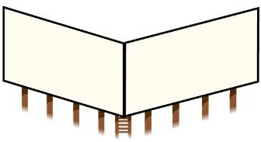 | A single structure having two sign faces in the shape of the letter V when viewed from above, with the sign faces oriented in different directions.
Side-by-side |  | A single structure having two sign faces on the same supporting structure and facing one direction. A single pipe, beam, conduit, or pole between two adjacent sign faces is not considered a supporting  structure.
Stacked (also known as “double  deck”) | 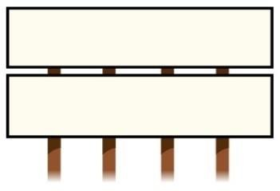 | Sign faces stacked above and below each other on the same supporting structure and facing one direction of travel, or two or more sign faces on two structures side-by-side or otherwise immediately adjacent to one another facing one direction of travel  at a single location.

Changeable message signs
A “changeable message sign” is an outdoor advertisement that uses technology, such as LED lighting, to periodically change the message displayed on the sign face.

Changeable message sign
The two types of changeable message signs defined by statute are electronic billboards and trimovement signs.

A changeable message sign can only be one of the following:
  - A single-face sign
  - A V-shaped sign
  - A back-to-back sign
Stacked or side-by-side signs cannot be changeable message signs. Requirements specific to changeable message signs:
- Messages cannot display copy that moves, appears to move, or flashes.
- Each message must be displayed for at least 8 seconds.
- Changeovers between messages cannot take more than 2 seconds.
- No changeable message sign shall be located within 300 feet of any building used primarily as a residence, unless the owner of the building consents in writing to the location of the changeable message sign.
- The permittee must provide up to two contact persons and phone numbers for every changeable message sign. The contact persons must have the ability and authority to make modifications to the display and lighting levels upon request by INDOT.
- If INDOT determines that the changeable message sign:
  - impairs the vision of the driver of any motor vehicle; or
  - otherwise interferes with the operation of a motor vehicle;
then upon request from INDOT, the permittee must take appropriate corrective action to fix the problem or cause the sign to be frozen in a dark or blank position within 12 hours.
- INDOT may direct the permittee to disable the changeable message sign:
  - in cases of emergency; or
  - when the contact persons do not respond to a request relating to a malfunction within 48 hours.
- The failure to respond to a request within 48 hours is also grounds to revoke the sign’s
permit.
- Changeable message signs must possess and utilize a light sensing device with automatic dimming capabilities to adjust the brightness of the sign, so that the maximum luminescence level is not more than three-tenths foot candles over ambient light measured at a distance of:

Sign face size | Distance measurement
300 square feet or smaller | 150 feet
Larger than 300 square feet, but equal or less than 378 square feet | 200 feet
Larger than 378 square feet, but equal or less than 672 square feet | 250 feet
Larger than 672 square feet (up to maximum sign face size of 1,000 square feet) | 350 feet

- These signs must be configured to default to a static display or freeze the sign in a dark or blank position in the event of a malfunction, and operated with systems and monitoring in place to either turn the display off or show a full black image in the event of a malfunction.

Other advertising forms
An advertisement does not have to be on a billboard sign to make it subject to outdoor advertising control laws and regulations. Those laws and regulations can cover anything with an advertising message (that is not an “on-premise” sign) in areas adjacent to control routes. It could be an advertisement on an object that is not a typical billboard. It could be on the side of a building. The structure itself is not what makes something an outdoor advertisement — rather, its location and the fact that it displays an advertising message or is intended to inform is what makes something an outdoor advertisement subject to control.
Other examples of what can be considered outdoor advertising if designated, intended, or used to advertise or inform (this is not an exhaustive list):
- Posters and notices
- Placards and boards
- Fascia signs and projecting signs
- Pole signs and canopy signs
- Models and devices
- Captive balloon advertising (not balloons in flight)
- Flag advertisements
- Price markers and price displays
- Wall murals
- Trucks/trailers (if stationary)
- Banners or bulletins
- Barn roofs
- Paintings or drawings
- Messages
- Placards

Where is outdoor advertising subject to control?

Control routes
Generally, INDOT controls outdoor advertising on the following roads (“control routes”) within the State of Indiana:
- The Interstate system
- The Federal-Aid Primary System as of June 1, 1991
- Scenic byways
- The National Highway System, including connectors
INDOT has mapping resources to help identify roadways that are part of control routes. As set out in 105 IAC 7-4-9, control routes are identified in an updated file available on this INDOT webpage: https://www.in.gov/indot/2781.htm

INDOT District Permits staff can help identify whether a particular location is on a control route.
Note: Control of outdoor advertising may be performed by a local government. If a local government is responsible for outdoor advertising control through an agreement with INDOT, the INDOT District Permits staff will refer the permit applicant to the appropriate office.

Adjacent area
INDOT controls outdoor advertising in the “adjacent area” along the right-of-way of control routes (as detailed further below, outdoor advertising is never located in the right-of-way).

Inside incorporated municipalities | Adjacent to and within 660 feet from the nearest edge of the right-of-way of a control route
Outside incorporated municipalities | In addition to the above area, signs are also subject to control if visible from the main-travelled way of the control route and erected with the purpose of  being read from such main-travelled way

Right-of-way and encroachments
In the interest of safe and efficient utilization of roadways, advertising is prohibited on INDOT right-of- way. The area within right-of-way boundaries must be devoted exclusively to public highway purposes.
Advertising that is illegally located on INDOT right-of-way, or that extends even partially into the right- of-way, is considered an illegal “encroachment.” An encroachment must be removed within 30 days; failure to do so may result in INDOT removing the encroachment and billing the responsible party for
the costs of removal, including any administrative costs, court costs and attorney’s fees.

How is outdoor advertising regulated?
INDOT regulates the location, spacing, size, and lighting of signs. In addition, the purpose for which the property is used is also an important factor.

Location
Outdoor advertising control takes into consideration the land use of the property, as well as other signs, structures, or buildings near the location of a sign.

Zoning
Signs must be located in areas zoned or otherwise used for commercial or industrial activity.

Zoned commercial/industrial areas
If the property is zoned commercial or industrial by a local government, INDOT can take that fact into consideration when determining if the property is suitable for outdoor advertising. However, INDOT’s determination is an independent one, and it is not bound by the local zoning designation.
For purposes of outdoor advertising, INDOT will recognize local zoning designations if that zoning is adequately supported by the local government’s comprehensive zoning plan. However, if there are facts indicating that the local zoning decision was made for the purpose of erecting outdoor advertising, then INDOT will not recognize the local zoning designation.

Unzoned land
If the area is not zoned by a local government (often the case in rural areas), it is within INDOT’s discretion to determine whether the area is question is actually used for commercial or industrial purposes (for example, proximate to a business or industrial building). Even if there is commercial/industrial activity occurring on the land, the sign has to be within 600 feet of that activity, and there are other restrictions on where signs can be located.

Limitations on signs in unzoned commercial/industrial areas:
  - To qualify to be eligible for a permit within an unzoned commercial or industrial area, a sign must also be located within 600 feet from the outer edge of regularly used building, parking lots, storage, or processing areas of commercial or industrial activity.
  - If INDOT determines that the area has a commercial/industrial activity, there are several additional restrictions on where the sign can be located:
- Signs cannot be located within 300 feet of any building used primarily as a residence (unless the owner of the building consents in writing to that particular commercial use or uses to be made of such lands)
- Signs cannot be located within 500 feet of any of the following:
  - public park, garden recreation area, or forest preserve
  - church

  - school
  - officially designated historical battlefield
  - museum or historical monument
  - safety rest or recreation
- Signs cannot be located within 750 feet of any strip of land, an interest in which has been acquired by the State for the restoration, preservation, or enhancement of scenic beauty.

Any building or other permanent structure used for commercial/industrial activity must:
- not be principally used as a residence;
- include customary facilities such as running water, functioning electrical connections, and adequate heating;
- be located on the same side of the control route as the sign; and
- have a permanent foundation that is built or modified for the activity. Any mobile structure being so used must:
  - not be a self-propelled vehicle,
  - remove all wheels, axles, and springs, and
  - be permanently secured on piers, pad, or foundation.

Examples of factors weighing in favor of an activity being commercial/industrial:
- The activity is maintaining all necessary business licenses as required by state or local law or ordinances.
- If the activity is performed by a corporation or a limited liability company, the entity maintaining all necessary registration to remain in good standing with the Indiana Secretary of State.
- The activity has a direct vehicular access from a public road that is normal and customary for entry and exit by the public to the activity, as well as adequate parking to accommodate public access.

What’s not a commercial/industrial activity:
- Signs or other outdoor advertising structures
- Agricultural, forestry, ranching, grazing, farming, and related activities, including produce stands and other seasonal stands
- Transient or temporary activities, including weekend or seasonal flea markets
- Railroad tracks, minor sidings, cell towers or other utility facilities

Scenic byways
Indiana has a Scenic Byways Program to recognize certain roadways. A roadway is eligible to be designated a “scenic byway” based on the road’s scenic, cultural, historic, archeological, recreational, or natural qualities. A list of byways and more information about the program can be found at www.in.gov/indot/2827.htm. Each scenic byway is defined, segment by segment, in 105 IAC 7-4-2.

Indiana does not allow new outdoor advertising to be erected on any control route designated as a scenic byway.

Nominations for new scenic byways
When a scenic byway has been nominated to the State’s Scenic Byway Committee, the following parties
receive notice:
  - All applicants with pending permit applications for any sign to be erected adjacent to the portion of the road that is nominated to become a scenic byway;
  - All permittees for whom a permit has been granted within the past 365 days for any sign to be erected adjacent to the portion of the road that is nominated to become a scenic byway;
  - All applicants with pending permit applications for any sign to be erected adjacent to any control route, which sign would be visible from the main-traveled way of the nominated road; and
  - All permittees for whom a permit has been granted within the past 365 days for any sign to be erected adjacent to any control route, which sign would be visible from the main-traveled way of the nominated road.
Once nomination has occurred, any pending permit applications for signs on or near the scenic byway are suspended, unless the applicant and INDOT enter into an agreement.
Any sign that is under construction (uncompleted) at the time that a scenic byway is designated will have its permit automatically revoked (and the construction must be removed at the expense of the sign owner and owner of the real estate where the sign is located, although just compensation will be paid by INDOT if “substantial effort” has been made to erect the sign).

Spacing of signs
For signs erected after October 4, 1971:
  - On the Interstate System and other limited-access roadways (e.g. freeways)* on control routes:
    - A sign may not be erected within 500 feet of another sign on the same side of the roadway.
    - Outside of incorporated municipalities, a sign may not be erected within 500 feet of the nearest edge of an interchange, intersection at grade, or rest area to be measured from the closer of the beginning or ending of pavement widening at the exit or entrance to the main-traveled way.
  - On all other control routes:
    - Outside of incorporated municipalities, sign may not be erected within 300 feet of another sign on the same side of the highway.
    - Inside incorporated municipalities, sign may not be erected within 100 feet of another sign on the same side of the highway.

*Limited access roadways are those where INDOT has declared or purchased access control rights from adjoining property owners and controls access to the roadway, either fully or partially.
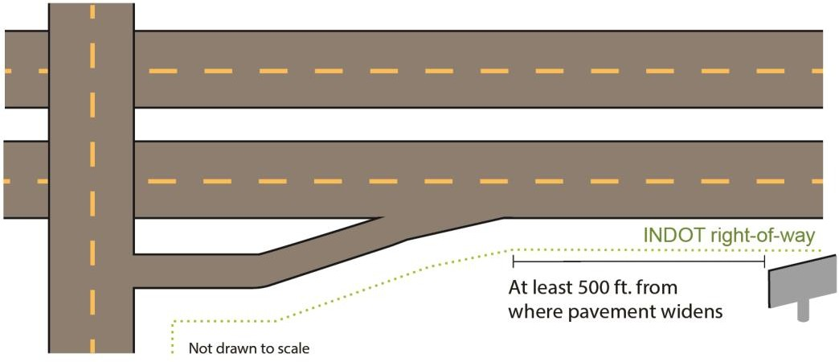
Area permittable for interchanges/intersections/
rest areas on limited access routes outside of municipalities

Size of signs
The maximum area of the face for any sign erected after October 4, 1971:
- Total area: 1,000 square feet
- Height: 25 feet
- Length: 60 feet

These measurements are calculated exclusive of “embellishments” (ornamental additions to the structure of the sign face), border, trim, ornamental base, apron, supports, and other structural members, so long as the exclusions do not exceed 20% of the area of the sign.
The area is measured by the smallest square, rectangle, triangle, circle, or combination thereof which will encompass the entire sign face.
Side-by-side signs and stacked signs are subject to the same maximum measurements listed above for the area that encompasses all parts combined, including all sign faces.
Double-faced structures (back-to-back signs and V-shaped signs) will be permitted with the maximum measurements being applicable for each side.

Lighting of signs
Lighting (also called illuminating) a sign is allowed, subject to a proper permit for the sign and the conditions below:
  - Signs that contain, include or are illuminated by any flashing, intermittent, or moving light or lights are prohibited.
  - Signs cannot direct light beams or rays of such intensity or brilliance as to cause glare or to impair the vision of drivers, or otherwise interfere with any driver’s operation of a motor vehicle.
  - Signs cannot be illuminated as to obscure or interfere with the effectiveness of an official traffic sign, device, or signal.
The installation of electricity hookups to supply power to sign lighting may entail additional permitting from the local government outside of an INDOT outdoor advertising permit. It is the applicant’s sole responsibility to obtain any additional permits needed to illuminate the sign.

Permits: Conforming and nonconforming signs
Any sign subject to outdoor advertising control requires a permit.
Sign owners bear responsibility to ensure their signs are erected and maintained in accordance with the permit issued for the sign. Violations are punishable as a Class C infraction (with penalties up to $500 per day) or revocation of the permit.
The next section describes the two types of outdoor advertising permits. The type of permit a sign is eligible for depends on whether the sign conforms with current laws.

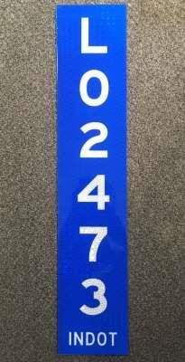Conforming signs
L-Plate

A blue tag (plate) with a number preceded by a letter L represents that the sign has been permitted as conforming to current requirements.
A “conforming sign” is a sign lawfully erected and in compliance with Federal and State laws and regulations. These signs are identified by “L-plate” tags.
Subject to permitting requirements, changes and improvements can be made to conforming signs so long as they also are in compliance with current laws, regulations, and all permitting requirements.
Changes and improvements affecting the structure of the sign would require an addendum to the original permit (see Chapter III.B, “Permit addendum”).
Examples of changes or improvements that would require an addendum (this list is not all-inclusive):
  - Changing to a different sign type (e.g. single-face sign changed to stacked sign)
  - Converting a traditional billboard to an electronic, changeable message sign
  - Adding lighting on the structure if lighting wasn’t part of the structure when
permitted by INDOT
  - Making other structural changes for aesthetic or other reasons
Changes to the sign’s message on its face — including embellishments that do not surpass size limitations — do not change a conforming sign in a way that would require an addendum.

Nonconforming signs
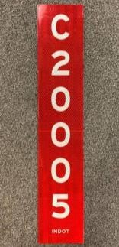A “nonconforming sign” is a sign which was lawfully erected in the past but does not comply with laws or regulations adopted at a later date, or which later fails to comply with current laws or regulations due to changed conditions. These signs receive a “conditional permit” and are identified by “C-plate” tags.
C-Plate

A red tag (plate) with a number preceded by a letter C represents that the sign is nonconforming, or that a conditional permit has been granted as allowed by law.
In order to maintain a nonconforming sign, the following conditions apply:
  - The sign must have been physically in existence at the time the applicable law or regulation became effective.
  - The sign must have been lawful on the effective date of the law or regulation and must continue to have been lawfully maintained.
  - The sign may be sold, leased, or otherwise transferred without affecting its status, but its location cannot be changed.
  - The sign must remain substantially the same as it was on the date the sign became nonconforming (“frozen in time”).

Nonconforming signs may not:
  - Be raised in elevation;
  - Be changed in size;
  - Be lit or illuminated (if the sign did not have lighting at the time it became nonconforming);
  - Have structural components changed
    - Example 1: Changing the number of supports
    - Example 2: Changing the material of the supports

“Customary maintenance or repair” on a nonconforming sign is acceptable, subject to the following conditions: The maintenance or repair is made to 25% or less of the sign during a one-year period, and only if such activity is not intended to prolong the duration of the nonconforming sign’s normal life. See the table in this section for a list of customary maintenance and repairs.
The sign may continue to exist with the conditional permit, as long as it is not abandoned, discontinued, obsolete, or destroyed, if permitted by law.
  - Abandoned: Cessation of use of a sign face for a period of at least 12 continuous months
  - Discontinued: Lack of advertising (other than obsolete or blank advertising, advertising of the permittee, or indicating that the sign is for rent) on a sign face for a period of at least 12 continuous months
  - Obsolete: For a period 12 continuous months:
    - Sign face does not contain advertising matter, or
    - Sign face contains an “available,” “for lease” or similar message that concerns the
availability of the sign itself, or
    - The sign is in need of substantial repair
  - Destroyed: Physically damaged to the point that, to be structurally restored to its existing physical configuration and size dimensions, requires the following:
    - In the case of wooden supports, replacement or structural repair using normal repair practices of 50% or more by item count of the supports during the repair period (wooden supports must be replaced with wooden supports).
    - In the case of metal supports, repair or replacement under normal repair practices during the repair period of:
      - 50% or more of the supports by item count, or
      - replacing 30% or more of the total length above ground of each broken, bent, or twisted support being repaired or replaced.
    - In the case of the face or structure, repair or replacement under normal repair practices during the repair period of 50% or more of the face or structure by area.

Customary maintenance or repair versus prohibited modifications of nonconforming signs

Acceptable customary maintenance or repair of nonconforming signs
Nailing, cleaning, and painting
Replacing nuts and bolts
Replacement of structural components, including vertical supports and sign faces, with the same material so
long as the sign is not destroyed
Changing the advertising message
Upgrading existing lighting for energy efficiency or worker safety
Addition of catwalks, safety cables, or handrails when required to resolve safety concerns by the Occupational
Safety and Health Administration or the Indiana Department of Labor

Prohibited modifications of nonconforming signs
Increasing the number of vertical supports or changing the vertical support materials, such as replacing
wooden supports with metal, or replacing I-beams with a monopole
Increasing the height of the sign
Changing the physical location
Changing the type of a sign structure (example: changing a V-shaped sign to a stacked sign)
Increasing the overall size or dimensions of the sign face, or any other addition of a sign face
Adding bracing (whether temporary or permanent), guy wires, concrete, or other reinforcing devices
Adding variable or changeable message capability
Adding lighting, either attached or unattached, to a sign that previously did not have lights, or
adding more intense lighting to an illuminated sign (except if done in accordance as set out above for safety
reasons)
Rebuilding, repair of (other than customary maintenance or repair on a nonconforming sign, which is limited to maintenance or repair to up to 25% of the sign during a one-year period), or re-erecting a sign structure after substantial damage from wear and tear, or other natural causes, unless INDOT has given its approval to do so
by granting an addendum to the sign’s permit
Relocating all or a portion of a sign
Turning the direction of a sign face
Any repair, maintenance, or improvement that causes the sign to be erected or maintained in a manner
contrary to its conditional permit

It is recommended that permittees wishing to perform maintenance or repairs on nonconforming (C-plate) signs contact INDOT to verify it is allowable before beginning work. Permittees are still
responsible for complying with applicable laws and regulations and cannot rely on representations made by INDOT.

Permit application process
An application is required to request a new sign permit, or for a “permit addendum” to modify the structure or type of an existing sign.
The permit applicant submits the application and any documentation electronically via INDOT’s Electronic Permitting System (“EPS”), and can pay the fee electronically using a credit card via EPS as well. For more details and a walk-through of submitting an application through EPS, see Chapter VI.

Contents of application
A separate permit application must be made for each sign in EPS.
The application must be verified and include, at a minimum, the following information:
  - Applicant’s name, address, email, and phone number
  - Sign owner name (company name), address, email, and phone number (if different than above)
  - Proposed location of the sign
  - Complete legal name and address of the property owner, as well as an accurate and complete description of the specific property interest held by the property owner in that real estate (for example, fee simple, lessee, or easement holder)
Examples of types of property interests
- Fee simple: Form of ownership
- Lessee: Someone who rents the property
- Easement holder: Some who has a specific right to access or use the property
  - A statement of whether the sign is located within an incorporated municipality or within the municipality’s extraterritorial jurisdiction
  - Location of the sign (road reference post number, roadway, and distance from crossroads)
  - Legal description of property (from property title or tax records)
  - Type of sign (e.g. back-to-back, side-by-side, etc.)
  - Sign face width and height (in feet)
  - Distance from the right-of-way
  - Date erected (if the sign has already been erected, for example in the case of a permit addendum)
  - GPS coordinates
  - Survey (completed by an Indiana surveyor identified by registration number)
  - Distance to nearest sign (in feet, on same side of highway)

  - Affidavit of property owner (or property owner’s authorized representative):
    - Demonstrating consent to:
      - the erection of the sign; and
      - the right of entry from time to time by INDOT employees or authorized agents on the real estate where the sign is located for purposes of inspection or removal of the sign.
    - In lieu of the affidavit signed by the property owner, the applicant may execute and submit an affidavit representing:
      - The applicant made a reasonable request to obtain the executed affidavit from the property owner, but the applicant's request was refused.
      - The applicant has the legal right to erect the sign, based upon its contractual documentation with the property owner;
      - The applicant notified the property owner of the right of entry from time to time by INDOT employees or authorized agents on the real estate where the sign is located for purposes of inspection or removal of the sign.
      - The affidavit must also include the correct name, mailing address, and electronic mail address of the property owner.
    - Upon receipt of the affidavit executed by the applicant under this subdivision, INDOT may require the applicant to provide additional information or documentation.
    - Affidavit templates are available on INDOT Permits Forms webpage.

Zoning documentation:
    - Actual current zoning must be noted as industrial, commercial, or industrial and commercial, or other (with explanation that the zoning at the location is primarily for the use of commercial or industrial activities actively soliciting commerce at the location)
    - A letter or other document signed by an authorized representative of the local governmental entity that provides the current zoning applicable to the sign's location.
    - In lieu of the letter or other document from the local governmental entity contemplated by this subdivision, the applicant may execute and submit an affidavit representing:
      - The applicant made a reasonable request to obtain the executed letter or other document on behalf of the local governmental entity, but the applicant's request was refused; and
      - The applicant has verified that the zoning is appropriate for the erection of the sign, and is also representing to INDOT what the current zoning classification is for the real estate upon which the sign would be located.

    - Upon receipt of a letter or other document signed by an authorized representative of the local governmental entity or the affidavit executed by the applicant, INDOT may require the applicant to provide additional information or documentation verifying the information or representations therein.
  - Information that details the specific location on the real estate where the sign will be erected and maintained, and how it will be maintained.
Location of a proposed sign
A stake or some identifying object should be placed at the proposed sign location, at or as near as possible to the right-of-way line to assist INDOT in investigating the proposed site.
  - Any other information or documentation reasonably related to the application.
The applicant should also make the property owner aware that once the sign is constructed, INDOT has the right to enter the property and inspect the sign.

Permit addendum
In the same way a permit is required before erecting a new sign, an application is also required before a permittee may make modifications to the sign’s structure (which generally is not going to be allowed for nonconforming signs). An application to modify an existing, permitted sign is known as a permit addendum. In general, the application
process mirrors a permit for a new application. All information in the original permit application must be reviewed to ensure compliance with all current Federal and State laws and regulations.

Incomplete applications
An incomplete application will not receive full review, but minor deficiencies may be cured promptly (within 15 days) after INDOT provides notice to the applicant to provide additional information or documentation.
The return of an incomplete application and any accompanying materials without full processing is not a final administrative action subject to appeal.

Permit application approval
Approval may be granted for applications that meet all necessary requirements.

Notification of approval
The permittee receives notification of the permit approval along with the assigned permit number tag designating the sign as either legally conforming (L-plate) or nonconforming (C-plate). The applicant (who can now be called the permittee) is required to affix the tag to the sign so it is visible from the right-of-way. If the sign is already in existence at the time the tag is issued, it should be affixed within 30 days.

Other permitting requirements outside of INDOT
INDOT’s outdoor advertising control permit requirements are in addition to any permit or licensing requirements of local governing bodies. INDOT’s permit approval may, but is not required to, occur after

other necessary permitting by other government entities (i.e. local permitting, power, environmental, etc.) The permit applicant can provide information about other permits in the INDOT permit application. If the proposed sign is subject to additional permit requirements outside of what INDOT requires to make the sign fully legal, the responsibility is on the applicant to obtain all other necessary permits. If INDOT learns that other permits have not been timely obtained as required, then INDOT’s permit will be revoked. The most prescriptive requirements apply, whether they are Federal, State, or local.
The issuance of the permit in no way implies INDOT’s approval of, or be intended to influence, any action pending before a local board, commission, or agency.

Completion of permitted work
No access from right-of-way
Access to the site of a sign for building, maintenance, or repairs cannot take place from INDOT right-of-way.
As is the case for all permits, the permittee should notify the assigned Permit Investigator within five business days of starting permitted work (e.g. erecting a new sign). A phone call or note submitted in EPS suffices.
The sign must be erected (or modification completed, if an addendum) within 365 days of the date the permit is issued. If work is not completed within that
time period, the permit will be revoked and any construction must be removed at the permittee’s
expense.
Once erected, the permit tag must be affixed to the sign, in a place visible from the roadway, within 60 days.
The Permit Investigator will conduct a post-work inspection to ensure that the sign was built as permitted, with the tag fastened to the structure in a place that is visible from State right-of-way.
Once erected, the permit allows the sign to stand for the life of the sign, as long as the structure remains compliant with Indiana law, including but not limited to the types of maintenance and repairs that are permissible.

Permit application denial
When INDOT denies a permit application, it will notify the applicant by letter setting forth the reasons. The applicant or property owner may appeal INDOT’s determination pursuant to 105 IAC 7-4-12.

Permit downgrade or revocation
INDOT may revoke a permit for any of the reasons listed in 105 IAC 7-4-15(a).
There may also be situations where a L-plated permit is “downgraded” to a C-plated permit due to changes in laws, regulations, zoning, circumstances, etc.
The permittee or property owner may appeal INDOT’s determination pursuant to 105 IAC 7-4-12.

Fee schedule for permit applications and other actions

Type of permit action | Fee
Sign permit application | $100.00
Sign addendum | $100.00
Transfer of ownership of sign | $40.00
Replacement permit plate | $25.00
Vegetation removal/tree trimming permit | $55.00

Required updates to permit records

Transfer of sign ownership
When one person or business buys a sign from another, the permit records need to be updated to show the transfer to the new sign owner, see 105 IAC 7-4-4. The update can be completed in EPS and requires a $40 transfer fee for each sign.
An update to permit records to show the transfer of sign ownership must be supported by proper documentation — such as a bill of sale that clearly identifies (1) the current owner, (2) the transfer of ownership, and (3) each sign by permit number. If necessary, affidavits may be submitted (templates can be found on the INDOT Permits Forms webpage).

Failure to adequately update permit records regarding the transfer of sign ownership (with proper documentation and fee) within 180 days of the effective date of the sale is grounds for INDOT to assess late fees ($100 per month, up to $400) or to revoke the permit. Late fees are owed by both the permittee and the transferee, jointly and severally.
For transfers of sign ownership that occurred before August 23, 2019, but for which the required transfer information has not been provided to INDOT: The required transfer information and fee must be provided by August 23, 2020. Failure to do so subjects the permittee and transferee to late fees and possible revocation, as noted above.
When a transfer involves a large number of signs, a bulk transfer can be done so long as the documentation provided to INDOT adequately identifies each sign by permit number and shows proof of ownership for each sign. Contact INDOT Central Office Permits staff for more information. The $40 transfer fee still must be paid for each sign listed.

Other updates
The permittee is obligated to provide an update to INDOT of any change in contact information (contact person’s name, mailing address, email) for either the permittee or for the property owner where the sign is located, see 105 IAC 7-4-11.

Unlike transfers in sign ownership, there is no fee for this update.
The permittee is required to notify INDOT within 120 days of actual knowledge of the change in contact information.
The permittee is obligated to provide an update to INDOT whenever the real estate (upon which the sign is located) is sold. The permittee must provide to INDOT written evidence of the sale, as well as contact information for the new owner, within 180 days of the permittee’s actual knowledge of the sale.
The current property owner should be made aware of INDOT’s right of entry relating to the sign.
As necessary, affidavits may be used (templates can be found on the INDOT Permits Forms webpage).

As is the case with transfers of sign ownership, the permittee can liable for late fees ($100 per month, up to $400) and even permit revocation for failure to provide these updates in a timely way.

Keeping permit plates visible; other upkeep

Replacement plates
A permitted sign must have a tag (plate) identifying its permit number fastened to it and visible from the right-of-way, see 105 IAC 7-4-8.
If INDOT determines that a sign does not have the current design of the permit plate fastened and visible as required, it may send written notice to the permittee of this fact.
If a replacement plate is needed, the permittee can order a replacement plate for a fee of $25 through EPS. The order must be made within 60 days of INDOT’s notice. The permittee must fasten the replacement plate in accordance with 105 IAC 7-4-8 within 60 days of receiving the plate.
As is the case with required updates to the permit record, the permittee can liable for late fees ($100 per month, up to $400) and even permit revocation for noncompliance.

Vegetation removal/tree-trimming permit
INDOT is neither required nor obligated to provide or maintain visibility of an outdoor advertising sign from roadways.
Anyone seeking to trim, prune, or remove vegetation, brush, or trees from State right-of-way must be first granted a tree-trimming permit. A request for such as permit must be submitted through EPS.
In accordance with the U.S. Fish and Wildlife Service Forest Management Guidelines for Informal Section 7 Consultations of Indiana Bats (Myotis Socalis) within the State of Indiana, there will be
no cutting/felling of trees greater than three inches in diameter at base height while Indiana bats may be present from April 1 through September 30.

A tree-trimming permit will have a limited time window for the permittee to act. Each permit is for one- time use only, for the right-of-way in the immediate area adjacent to a specific sign.
It is the permittee’s responsibility to obtain any necessary permission from property owners where the permittee seeks to remove vegetation or trim trees. It is the permittee’s responsibility to avoid removing vegetation on other property absent permission, and it is also the permittee’s responsibility to ensure that they (or their contractor) are familiar with property boundaries where the sign is located.
Failure to adhere to these standards can result in revocation of the sign permit.

Walk-through of EPS permit application process
As referenced in this document, INDOT has a paperless, electronic method to submit permit applications including applications for outdoor advertising permits.
For a technical review of how EPS works, review the EPS Manual.

To get started, visit the EPS front page.

Registering for an account with EPS
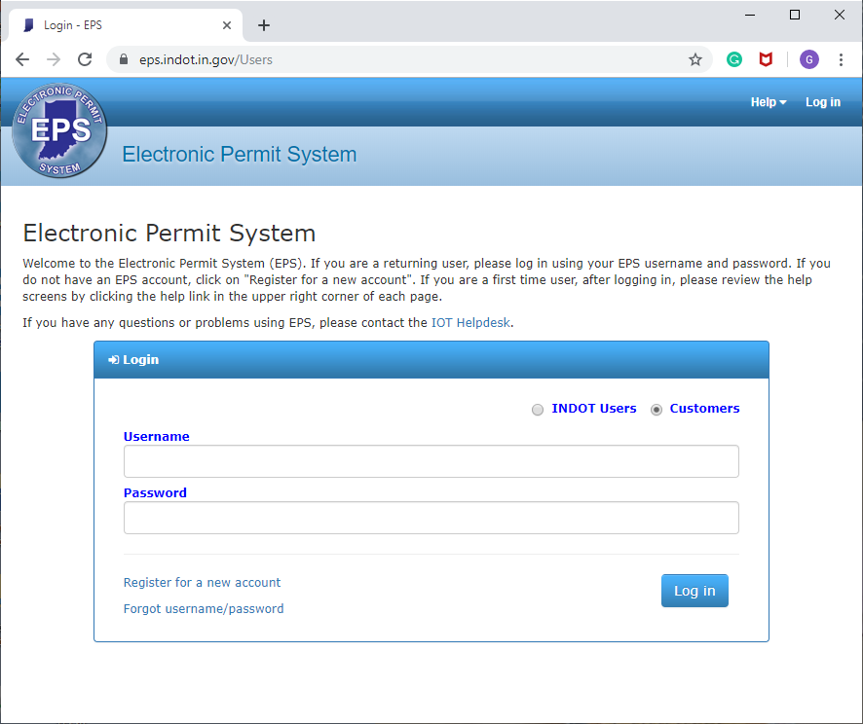You can set up an account by performing the following tasks:
  - Create a username
  - Create a password
  - Provide the following contact information
    - First, last name
    - Email
    - Address
    - Phone

Logging into EPS
  - Ensure the radio button is selected to
“Customers” (should be the default)
  - Enter username
  - Enter password
  - Click “Log In” button

Applying for a permit
  - Once logged in and on the main page for EPS, click the green “+ New Permit” button
  - Read Applicant’s Acceptance Agreement. To proceed, click the green “I Agree” button

On “Permit Type” page
    - Under “Select Permit Type / Subtype”
      - Next to “Permit Type,” in drop-down menu, select “Outdoor Sign”
      - Next to “Permit Subtype,” in drop-down menu, select “Billboard”
    - On this and the following pages, click the blue “Next” button at the bottom to proceed
to the next page
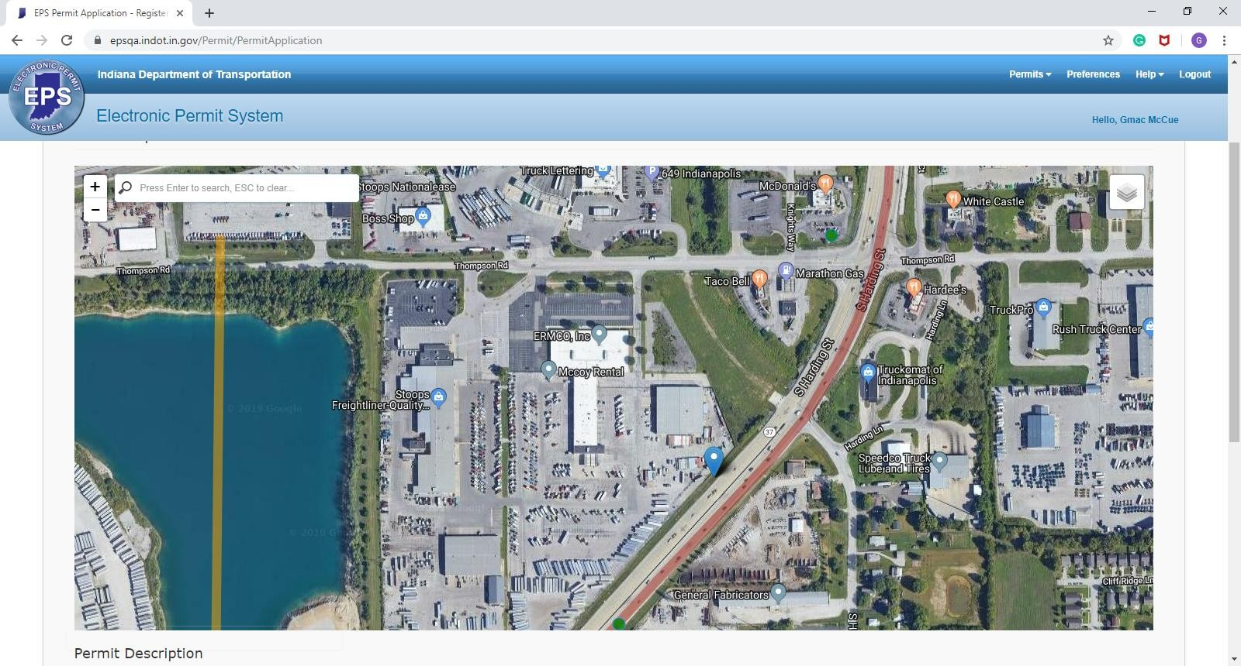

On “Select Location” page
    - On the map, zoom in to area to drop an “anchor” at the location of the sign/proposed sign.
    - Once an anchor has been dropped on the map, details of the location will automatically
populate under “Permit Description”
      - District
      - County
      - Permit Investigator with contact information
      - Road
      - Longitude and latitude
      - Radio buttons
        - Whether road is limited access
        - “Will this project directly or indirectly impact an INDOT environmental mitigation site?”
  - On the “Applicant Info” page, enter information in the following fields:
    - Applicant name, address, phone, email (note that this may be different than the contact person, which is entered below)

    - Company (if needing to add a new company, refer to the EPS Manual)
    - Whether the company is a consulting firm or contractor doing work on behalf of a client (yes or no)
    - Whether company is eligible to have its fees waived (checkbox) (billboard permits are not eligible for fee waivers).
    - Contact person name, phone, email (this is important in case that person who is the designated contact for the permit is a different person than who submitted the permit application)

On the “Details” page
    - Details and permit fee will be displayed.
    - Enter estimated project start date
    - Enter estimated project end date
    - Enter project location: The project location should be identified from the nearest state road intersection and from the nearest city street or county road intersection.
(e.g. “2 miles south of US-40 and 150 feet north of Davis Road”)
    - If applicable, enter customer work order number.

On the “Sign Details” page
    - Select the sign location diagram (can only select one), choose the option that is most applicable
      - Limited access right of way
      - Non-limited access right of way
      - Interchanges
      - Grade intersection, limited access
      - Grade intersection, other
      - Unzoned area
      - Other
    - Does the sign principally advertise activities taking place on the property where the sign is located? (yes or no) To review, if the sign ONLY advertises activities taking place on
the property, it is considered an “on premise” sign and a permit is not necessary.
    - Select from drop-down menu, existing or proposed sign
    - Select from drop-down menu, direction of travel (North, South, East, or West)
    - Select from drop-down menu, side of highway (left or right)
    - Estimated build date
    - Estimated feet to nearest sign (excluding official, directional, on-premise and ‘for sale’
signs)
    - Feet from right-of-way line of highway
    - Estimated distance and direction from sign to nearest intersection/ramp: Enter distance, direction (North/South/East/West) and ramp description
    - Primary zoning classification drop-down
      - Zoned industrial
      - Unzoned industrial
      - Zoned commercial

      - Unzoned commercial
      - Other (agricultural, residential, etc.)
      - Encroachments
    - City or county permit number (if applicable)
    - Within city limits (yes or no): If yes is selected, enter the controlling municipality
    - Can the sign be seen from a scenic byway (yes or no)
    - Was the property rezoned for the purpose of erecting a billboard after March 15, 1986? (yes or no)
    - Was any zoning action taken by the applicant or the property owner for the purpose of erecting a billboard after March 15, 1986? (yes or no)
    - Distance from a building being used primarily as a residence (in feet)
    - Distance to public park, garden, recreation area or forest preserve, church, school, and historically designated area, museum or publicly owned rest area (in feet)
    - Distance from a state restoration, presentation or enhancement of scenic beauty which is publicly controlled and maintained (in feet)
    - Estimated height (in feet, from ground to top of sign face)
    - Width of face
    - Height of face
    - (Area of face will automatically be calculated based on width and height)
    - Sign type drop-down
      - Single face
      - Back-to-back
      - V-type
      - Side-by-side
      - Double deck (stacked)
      - Other
    - Number of supports (include not only vertical poles but also brackets connecting the sign to the ground)
    - Material (drop-down: wood, steel, monopole, other) (If other, the applicant then must specify the material)
    - Illuminated (yes or no)
    - Changeable message sign (yes or no)
  - On the “Property owner details” page, enter name, address, phone and email of the property owner

On the “Attachments” page
    - Click the “Select File” button, browse to find file
    - Next to “File Title” enter description of file
    - Click green “Upload” button

On the “Review and Pay” page
    - Review information and application fee
    - Select a payment method (credit or IN.gov)
      - If you plan to submit permits on a regular basis, the IN.gov website tells you why it’s beneficial to sign up with IN.gov as a subscriber. If you are not already an IN.gov subscriber, you can become one by enrolling at
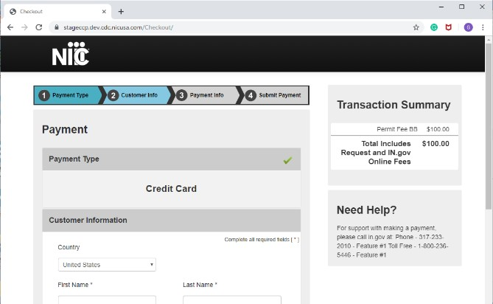http://www.in.gov/accounts, and then click on account agreements on the left side of the screen. Once you are an IN.gov subscriber, you can simply enter your subscriber credentials at the time of application, and your company will receive one itemized monthly bill
for all permits applications submitted each month. If you are only submitting the occasional permit, the instant access method is what you need. With instant access, you can pay for the permit by credit card at the time of application.

Next steps after submitting the application in EPS
  - After the application and payment is submitted via EPS, INDOT’s review begins.
  - Additional information requests and questions for the applicant are communicated electronically via EPS (look under “Public Messages”).
  - After a complete application is reviewed, it will be approved or denied.
    - If approved: A copy of the approved permit, along with all necessary attachments, including Outdoor Advertising General Provisions, are sent via EPS to the permittee.
    - If denied: The applicant will be notified via EPS with an explanation as to why the application was not approved.

Outdoor advertising permit FAQ

Q. Why do I need a sign permit if my sign is off INDOT’s right-of-way?
A. The Highway Beautification Act of 1965 (HBA) required all states to make provisions for effective control of outdoor advertising in adjacent areas along right-of-way or risk Federal highway funding.

Q. Can I place a sign on INDOT’s right-of-way?
A. No, all advertising signs on INDOT’s right-of-way are prohibited.

Q. What if I have business along the right-of-way and want to place a sign for my business? Do I have to get an INDOT permit?
A. In most cases, no, it will be considered an “on-premise” sign. NOTE: On-premise changeable message signs cannot have any off-premise outdoor messages intermixed. If you have doubts about whether your sign is on- or off-premise, contact the local INDOT District Permits staff.

Q. Are all roadways regulated by the HBA?
A. No, only “control routes.” See the section of this Guide on control routes, which provides resources to determine which roadways are control routes.

Q. I wish to apply for a sign permit. What do I do first?
A. First: Contact the local INDOT District office to speak to a Permits Investigator. The Investigator, will in most cases, do a sight review and advise you of any particular rules or regulations that may apply. This will likely save you time and money. Click here for contact information in your area.

Second: Apply for the sign permit online via EPS.

Contact information

INDOT Central Office | State Permit Executive and staff 317-233-6938  permits@indot.IN.gov Website: INDOT Permits
INDOT Regional Offices | Current information can be found on the INDOT Permits webpage

